POWER DISTRIBUTION TABLE

|  |  |  |
| --- | --- | --- |
| UNIT NAME | SAMPLE RATE (Hz) | POWER (mW) |
| IMU – BNO085 | 400 | 45.45 |
| GPS module – Ublox Neo 6M | 5 | 165 |
| Oled display – SSD1327 | - | 13.2 - 198 |
| Node MCU |  | 1. - 495 |
|  |  | 454.65 - 903.45 |

Typical hours of operation – 20 Hr

Operating Voltage – 3.3 V

Energy consumption – {454.65 - 903.45} x 20 = {9093 – 18069} mWh

= {9093 – 18069} ÷ 3.3 = {2755.45 – 5475.45} mAh

Operating power of Brake light = 1 W

Typical hours of operation = 10 Hr

Typical operating voltage = 7 V

Energy consumption = 1 x 10 = 10 Wh

= $\frac{10×1000}{7}=$ 1428.57 mAh

**NET ENERGY CONSUMPTION = {4184.02 – 6904.02} mAh**

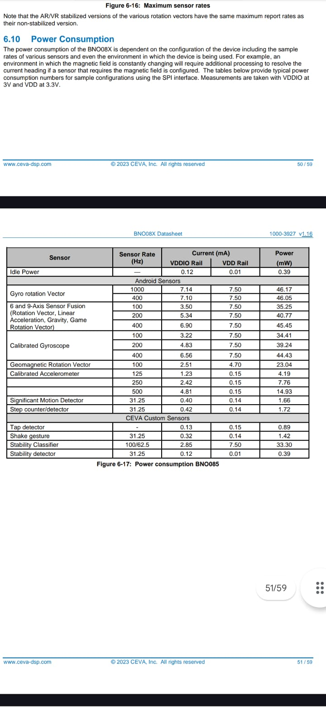Other options :-